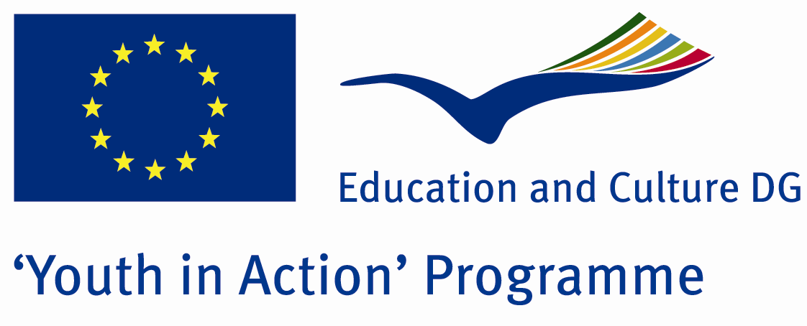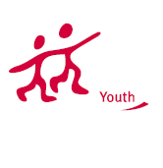

Yipee, Healthy Life
Without Technology



ACTION 1.1 – Youth Exchange

01-08th August, 2011

Mugla, TURKEY

ACTION 1.1 Youth Exchange
01-08th August, 2011
Mugla, TURKEY

Please contact directly to;
adventurerpeacepigeons@gmail.com

Project Summary;

We aimed that we learn how we can live without technology….No phone…No computer.. No net…. No clock… No TV…. No radio…. There are animals….. We….. Houses…. Nature… We will stay in a village… We try to choose a village near sea… We will take our milk from the cows and take our eggs from the chickens… Maybe we can stay in a tent.. We will make Turkish bread with public women and eat this bread… If we can success, we will go to fishing… It will be very cool and fantastic travel… So, we will learn the importance of friendship and chatting… Of course special country night and parties will be.. But the main idea is friendship and to learn everything about technology… If we use the technology for good thing, it is not harmful but you know technology is killing the friendship and chatting..Even children don’t play with together anymore because of the computers..Their creativity skill is absent… When we were children, we made our toys ourselves…. We learnt everything ourselves… By doing.. By living… And now we know the importance of everything… Because we know what it means that to live without them..And our participants will learn this.. It will be great experience for everybody….. If you are interested in this Project, please send your part3 by fax…

Project Title; Yipee, Healthy Life Without Technology

Date and Venue ; 01-08th August, 2011 Mugla, Turkey .

Target Group ; Municipalities, City Councils and Non-Governmental organizations,
youth groups,culture and art groups,e.t.c

Participants ; 5 people from each country (over 18 -25 ). Totally 8 countries.

Conditions ; Accommodation, board and programme costs will be financed through European Commission Youth in Action Programme (Action 1.1). Travel costs will be reimbursed in 70% (APEX Tarrifs). Organizations from all 27 EU member countries plus Liechtenstein , Norway and Iceland are eligible to take part.

Working language: English

Organizer; Muğla Doğal Yaşam Grubu…

How to apply: If you are interested, please send your Part III forms to
0090 216 483 21 67 by FAX please. (Fulfilled Part III which you can find in the attachment, of course signed and stamped) ..

Note: jpeg is not allowed..please send by fax…

Next step 2;
Original send via regular post to this address please:

Ertan DERİN
Öner İnşaat
Abdulhalik Renda Cd.
Parlar Sk. No:4 Pendik/İSTANBUL

If you have any questions you may contact with: adventurerpeacepigeons@gmail.com

Deadline for application; until 20th January 2011.

For Further information:
Contact Person
Ertan DERİN
Öner İnşaat
Abdulhalik Renda Cd.
Parlar Sk. No:4 Pendik/İSTANBUL

e-mail : adventurerpeacepigeons@gmail.com
Mobile : 0090 542 393 93 90
Fax : 0090 216 483 21 67

